How Ocean Acidification was Implicated in Causing Coral Decline

The Great Barrier Reef, off the coast of Queensland, Australia, is the largest coral reef system in the world, composed of over 2,900 individual reefs and spanning a length of over 2,300 kilometers (1,400 miles). Selected to be a World Heritage Site by UNESCO in 1981, the Great Barrier Reef generates the equivalent of over two billion US dollars per year in tourism. The reef system plays a central role in the cultures of Aboriginal Australians and Torres Strait Islanders living on the coast, and is a defining feature in the culture of Australia as a whole. It’s also important to the ecosystem—many endangered species live in the reef system, as well as a diversity of other marine life.

One Tree Island is one of the over 900 islands in the Great Barrier Reef, with a land area of just 18.5 acres, smaller than ten city blocks. It is home to the surrounding One Tree Island reef, one of the most protected in the Great Barrier Reef—it falls under category Ia, the most stringent of the International Union for the Conservation of Nature (IUCN) protected area categories. In 2014, a team led by Rebecca Albright and Ken Caldeira, two scientists working at the Carnegie Institution for Science’s Department of Global Ecology, created what reporter Ed Yong describes as a “giant soda stream” at One Tree Island. Using this device, they pumped caustic soda, or lye, directly into the waters surrounding One Tree Island reef. With this experiment, Albright and Caldeira aimed to finally catch a culprit of coral decline that scientists had been chasing for the past decade.

Threatened Corals, Threatened Oceans

The Great Barrier Reef lost over half of its coral cover from 1985 to 2012. Since marine biologists first noticed the dramatic worsening of coral health, scientists have been investigating possible causes and trying to think of solutions. When we look at a coral reef, what we see is mostly its inorganic calcium carbonate, or CaCO­­3, structures. Complex colonies of small animals—the true corals—live in the reefs, and secrete calcium carbonate to build the structures. Other small organisms, such as algae and protists, also live in the reefs, and are often in symbiotic, or mutually beneficial, relationships with corals. Because reefs provide a habitat for so many organisms, many factors could cause problems in any single coral reef, and pinpointing true causes of coral reef decline is very difficult. Prior to the 21st century, scientists confirmed one primary cause of coral reef decline—the rising ocean temperature harming the coral animals living inside. Rising water temperatures weren’t the only cause of coral decline, though. In their experiment, Albright and Caldeira’s team were investigating whether ocean acidification, the process of ocean water becoming more acidic as it soaks up the increasing amounts of carbon dioxide in the atmosphere, was another primary cause of coral decline.

Scott C. Doney, a senior marine chemist and geochemist at the Woods Hole Oceanographic Institution in Massachusetts, describes why acidification could harm corals and other marine organisms in his 2006 *Scientific American* article, “The Dangers of Ocean Acidification.” When carbon dioxide, or CO2, dissolves in water, or H2O, the two substances combine to form carbonic acid, or H2CO3. Seawater is naturally slightly alkaline, sitting at around 8 on the pH scale, where 7 is neutral, and lower numbers are more acidic. The presence of carbonic acid brings ocean pH down—by 2006, the pH of the ocean had already fallen by 0.1 relative to pre-industrial levels. This poses a problem for coral reefs, since the more acidic oceans are, the more easily their CaCO3 structure dissolves, and the harder it is for the CaCO3-secreting coral animals to replace it. A change of 0.1 on the pH scale already slows down coral growth, but Doney warned that a larger change could completely dissolve coral structures, and harm other organisms with calcium carbonate shells, as well. For these reasons, scientists strongly suspected ocean acidification to be a serious threat to the entire marine ecosystem, especially as the pH of seawater was expected to fall another 0.3 by the year 2100.

A Quest for Evidence

To confirm their own suspicions and make a solid argument towards policymakers and the general public for curbing acidification, the scientific community now needed to find concrete evidence of acidification’s impact on coral reefs. In 2006, Doney’s time of writing, ocean acidification was a fairly new concept, and scientists had only begun to consider its harmful effects. Over the following years, scientists faced the challenge of distinguishing the effects of ocean acidification from those of ocean warming, which is also an effect of climate change. For example, although biologists had plenty of evidence that coral growth was slowing, they could not conclude solely from this evidence which the cause was. To find evidence of ocean acidification harming marine organisms, then, scientists had to find some way to distinguish between these two possible causes.

In the decade following Doney’s article, scientists used many different methods to try to distinguish the effects of ocean acidification from those of ocean warming. One approach was comparing data that scientists had collected and published—in 2013, a team of three researchers at Aberystwyth University in Wales published such a meta-analysis, which used differences in temperature and acidity in the locations in which data was collected to draw distinctions between the effects of warming and acidification. Their results were complex. They did find that ocean acidification had negative effects on many calcifying organisms, which are organisms that secrete CaCO3 (i.e. to build their calcium carbonate shells). Calcifying animals were not impacted equally by acidification, however—mollusks and crabs are both calcifying animals, but mollusks were the most negatively impacted by acidification, while crabs and other crustaceans were almost untouched, because they are able to regulate their internal pH. Scientists tried a few new data collection approaches as well. The Benthic Free Ocean CO2 Enrichment process, or Benthic FOCE for short, was a clever and promising approach used by a team of scientists led by David Kline, a coral reef ecologist at the University of California, San Diego, in 2012. This method allowed scientists to control the exact pH of microcosms, or communities of marine life. The Benthic FOCE method required building large enclosures around these microcosms, though, which would be very costly for any team using the method.

By 2016, scientists using all of the above methods, among others, had collectively generated data showing the extent to which ocean acidification impacted many marine organisms, but coral was still a mystery. In 2016, a group led by Elvira S. Poloczanska, a researcher at the Global Change Institute of the University of Queensland, published a literature review in the journal *Frontiers in Marine Science*, which found that evidence for the effects of ocean acidification on coral was “scarce, with temperature effects presently dominating.” Essentially, in other scientists’ meta-analyses, the change in coral growth rates over time matched too closely with what would happen under ocean warming effects, so much so that it was as if ocean acidification didn’t have any impact at all! Though this didn’t prove anything on its own, it seemed to suggest that despite scientists’ longstanding suspicions, ocean acidification wouldn’t impact corals after all. Scientists still sought conclusive evidence either way, as Australia’s beautiful coral reefs, the beloved face of marine environmental science, would play a huge part in determining how much publicity the issue of ocean acidification gets. Even in Doney’s original 2006 *Scientific American* article, one of the pull quotes highlights the impact on coral: “Many coral reefs are already in decline, and ocean acidification may push some over the edge into nonexistence.” The question now was, will ocean acidification really have the power to push coral reefs over the edge?

A Giant Soda Stream

Albright and Caldeira, the two Carnegie scientists, came together in 2014 at One Tree Island with the purpose of answering this question. In addition to being researchers in the Department of Global Ecology, Caldeira is a professor at Stanford, and Albright had been chipping away at this question since 2010 by studying the effects of ocean acidification on individual species of coral. Their strategy was the same as that of previous groups who used the costly benthic FOCE method: isolate a community of organisms—in this case, a portion of the coral reef—and alter the pH of the surrounding waters, to see whether coral health is impacted by the change in acidity. Albright and Caldeira’s “giant soda stream” allowed them to scale up this method significantly, without using the costly benthic FOCE technology.

The reef surrounding One Tree Island is divided into three lagoons, which the researchers call the First, Second, and Third Lagoons. The three lagoons are all submerged during high tide, but during low tide, they have different water levels. Albright and Caldeira’s team of scientists conducted their experiment on a reef flat between the First and Third Lagoons, taking advantage of the fact that because of the lagoons’ different water levels, water flows unidirectionally from the First Lagoon to the Third Lagoon twice daily, when the tide ebbs.

(Below: Figure 1 and caption from Albright et al.’s 2016 paper)

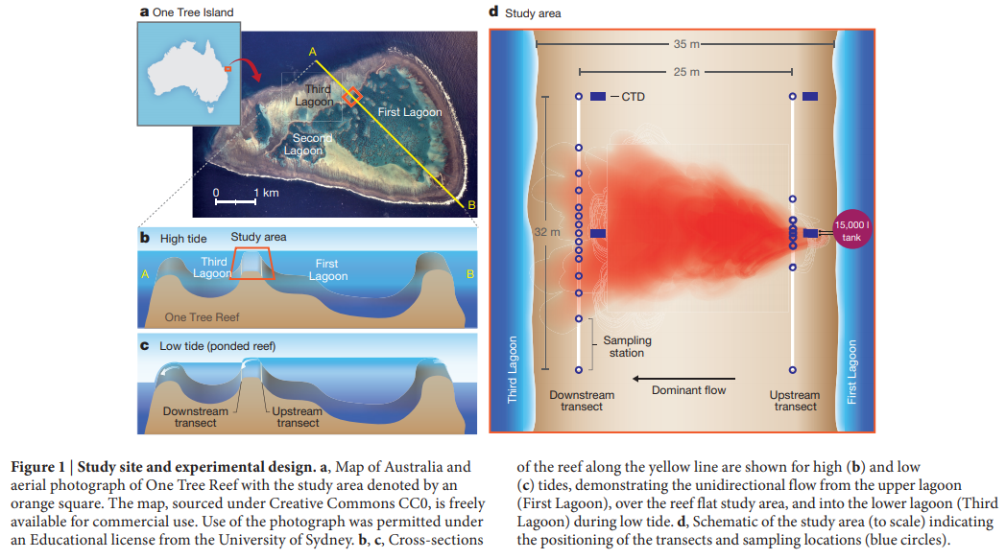

Every day during the experiment, Albright, Caldeira, and their team filled a 15,000-liter inflatable tank with a mixture of seawater, sodium hydroxide (or NaOH), and a harmless dye. They used sodium hydroxide, also known as caustic soda or lye, because it is one of the simplest alkaline molecules, so it decreases the acidity of seawater without any side effects. They also included a dye to track water movement, which let them calculate the corals’ growth rates by telling the scientists what the pH in the surrounding waters ‘should be.’ Because the production of CaCO3 changes water pH, the researchers can compare this value with the measured pH to figure out how fast the corals were growing during the experiment. As the tide ebbed each day, they released the mixture “upstream” of the study area, at the First Lagoon. Because of Albright and Caldeira’s choice of location, the mixture always flowed steadily into the study area, where they set up water sampling stations. They ran this experiment for 22 days, 7 of which were control days in which no NaOH was added. After analyzing all the samples, it was clear that reduced acidity was bolstering coral growth—the data showed that reducing ocean acidity to pre-industrial levels increased coral growth levels by 15%, on average. Albright and Caldeira’s team published their results in *Nature* in March 2016, the first scientific evidence that ocean acidification truly posed a threat to coral growth.

They also followed up this experiment with a similar one using the same apparatus, where instead of using NaOH to reduce ocean acidity, they pumped CO­2 into the water to increase its acidity. The results complemented their first: at the acidity levels scientists project we’ll see in a hundred years, the rate of coral growth is expected to decline 40%, on average, from present-day levels. Ed Yong compared the two experiments nicely—if their 2016 results showed the “ghost of corals past,” these results, published in 2018, showed the “ghost of corals future.”

Moving Forward

Albright and Caldeira’s pair of experiments not only confirmed that ocean acidification was a threat to corals, it also demonstrated the severity of the acidification threat, which is larger than scientists had previously suspected. Knowing this, coral researchers are now working to protect coral reefs from the effects of climate change. Many of these scientists still believe that we must stop climate change to save coral, but those who are less optimistic about this approach are trying to find ways to save corals even in the face of acidification. Among other strategies, some researchers are looking at which types of coral hold up most strongly against acidification to examine their traits or protect them, while some are performing experiments to see how adaptable various corals will be to climate change.

In May of this year, Albright and Sarah Cooley, Director of the Ocean Acidification Program at Ocean Conservancy, a nonprofit environmental awareness group, published a review of strategies for protecting coral diversity in the face of ocean acidification, looking at the emergence of new strategies, as well as new data on old strategies. Despite the wide range of strategies that have been invented as more researchers turn their attention to acidification and coral reefs, many are costly to implement, and require more research before we can implement them—for example, scientists have tried adding alkalinity to the water the same way Albright and Caldeira did in their experiment, but we have no idea how this alkalinity would affect the rest of the marine ecosystem.

(Below: branching diagram of strategies, from Albright and Cooley’s 2019 review)

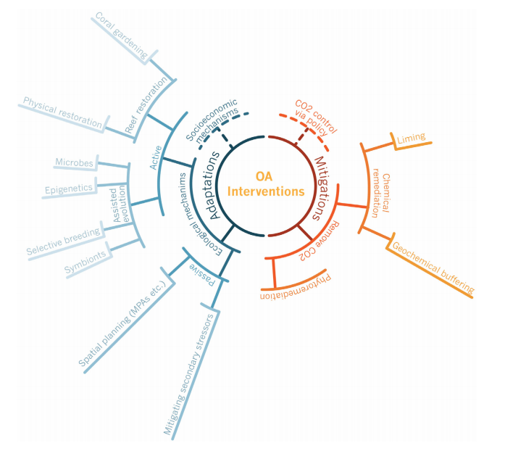

Nevertheless, Albright and Caldeira’s groundbreaking work has tied ocean acidification to the health of corals, both making acidification more prominent as an issue that cannot be ignored, and providing more clues to how we can save our corals from extinction. With scientists exploring so many different approaches in the wake of their work, we are likely to see progress soon towards understanding and fixing the decline of our oceans’ corals.

Further Reading

Albright, Rebecca, and Sarah Cooley. “A Review of Interventions Proposed to Abate Impacts of Ocean Acidification on Coral Reefs.” *Regional Studies in Marine Science* 29 (May 2019): UNSP 100612. doi:[10.1016/j.rsma.2019.100612](https://doi.org/10.1016/j.rsma.2019.100612).

Albright, Rebecca, Benjamin Mason, Margaret Miller, and Chris Langdon. “Ocean Acidification Compromises Recruitment Success of the Threatened Caribbean Coral Acropora Palmata.” *Proceedings of the National Academy of Sciences of the United States of America* 107, no. 47 (November 23, 2010): 20400–404. doi:[10.1073/pnas.1007273107](https://doi.org/10.1073/pnas.1007273107).

Albright, Rebecca, et al. “Reversal of Ocean Acidification Enhances Net Coral Reef Calcification.” *Nature*, vol. 531, no. 7594, Mar. 2016, pp. 362–65. *Crossref*, doi:[10.1038/nature17155](https://doi.org/10.1038/nature17155).

Andersson, Andreas, David Kline, Peter Edmunds, Stephen Archer, Nina Bednaršek, Robert Carpenter, Meg Chadsey, et al. “Understanding Ocean Acidification Impacts on Organismal to Ecological Scales.” *Oceanography* 25, no. 2 (June 1, 2015): 16–27. doi:[10.5670/oceanog.2015.27](https://doi.org/10.5670/oceanog.2015.27).

California Academy of Sciences. “Rebecca Albright.” Accessed November 5, 2019. <https://www.calacademy.org/learn-explore/science-heroes/rebecca-albright>.

Carnegie’s Department of Global Ecology. “Biographies for Ken Caldeira.” Accessed November 7, 2019. <https://dge.carnegiescience.edu/biographies-ken-caldeira>.

Davis, Kay L., et al. “Fifty Years of Sporadic Coral Reef Calcification Estimates at One Tree Island, Great Barrier Reef: Is It Enough to Imply Long Term Trends?” *Frontiers in Marine Science*, vol. 6, June 2019, p. UNSP 282. *Web of Science*, doi:[10.3389/fmars.2019.00282](https://doi.org/10.3389/fmars.2019.00282).

Doney, Scott C. “The Dangers of Ocean Acidification.” *Scientific American*, doi:[10.1038/scientificamerican0306-58](https://doi.org/10.1038/scientificamerican0306-58). Accessed 7 Nov. 2019.

“Great Barrier Reef.” *Wikipedia*, November 3, 2019. <https://en.wikipedia.org/w/index.php?title=Great_Barrier_Reef&oldid=924441922>.

Harvey, Ben P., Dylan Gwynn‐Jones, and Pippa J. Moore. “Meta-Analysis Reveals Complex Marine Biological Responses to the Interactive Effects of Ocean Acidification and Warming.” *Ecology and Evolution* 3, no. 4 (2013): 1016–30. doi:[10.1002/ece3.516](https://doi.org/10.1002/ece3.516).

“IUCN Protected Area Categories.” *Wikipedia*, 16 Dec. 2018. <https://en.wikipedia.org/w/index.php?title=IUCN_protected_area_categories&oldid=873953503>.

“Ocean Acidification Already Slowing Coral Reef Growth.” *ScienceDaily*, <https://www.sciencedaily.com/releases/2016/02/160224145558.htm>. Accessed 31 Oct. 2019.

“One Tree Island.” *The University of Sydney*, <https://sydney.edu.au/science/our-research/research-facilities/one-tree-island.html>. Accessed 7 Nov. 2019.

Poloczanska, Elvira S., et al. “Responses of Marine Organisms to Climate Change across Oceans.” *Frontiers in Marine Science*, vol. 3, 2016, p. UNSP 62. *Web of Science*, doi:[10.3389/fmars.2016.00062](https://doi.org/10.3389/fmars.2016.00062).

Torda, Gergely, Jennifer M. Donelson, Manuel Aranda, Daniel J. Barshis, Line Bay, Michael L. Berumen, David G. Bourne, et al. “Rapid Adaptive Responses to Climate Change in Corals.” *Nature Climate Change* 7, no. 9 (September 2017): 627–36. doi:[10.1038/NCLIMATE3374](https://doi.org/10.1038/NCLIMATE3374).

Yong, Ed. “What a Giant Soda Stream Reveals About the Fate of Corals.” *The Atlantic*, 14 Mar. 2018, <https://www.theatlantic.com/science/archive/2018/03/soda-stream-coral-reefs/555572/>.